Dairy Dataset Information
Dataset Overview
- The dataset focuses on dairy product sales, inventory management, production analysis, customer demand, pricing, shelf life, and profitability. The SQL queries are used to extract business insights such as revenue trends, stock management, product performance, customer purchasing behaviour, and operational efficiency.

- The project demonstrates how SQL can be applied in real-world business scenarios to support decision-making in the dairy industry.

Important Business Insights & Key Findings
Q1: Total revenue generated by each product

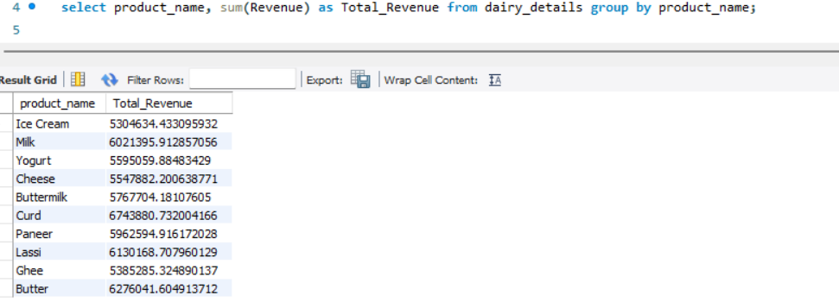
Observation:
- The analysis identifies the total revenue generated by each dairy product, helping businesses understand which products contribute the most to overall sales and profitability.
- The curd product has the highest revenue among all the other products.
Q2: Give Brand with the highest total revenue
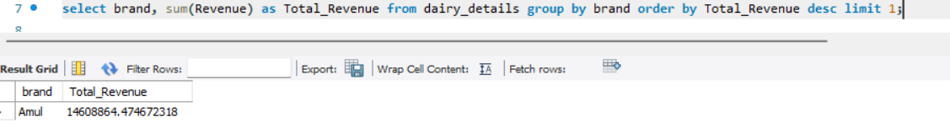

Observation:
- The project determines the brand with the highest total revenue, which helps management identify the strongest performing brand in the market.
- Amul brand is considered as the strongest performing among all the brands.

Q3: Give Monthly revenue trend across all products

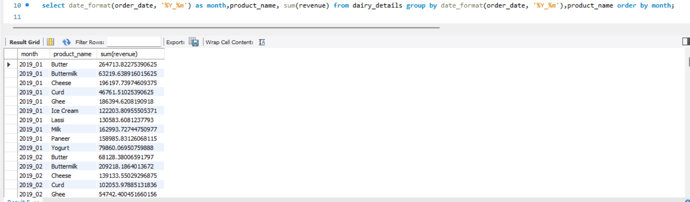
Observation:
- Monthly revenue trends help businesses track seasonal demand patterns, sales growth, and periods of low performance for better planning and forecasting.

Q4: Products below the minimum stock threshold
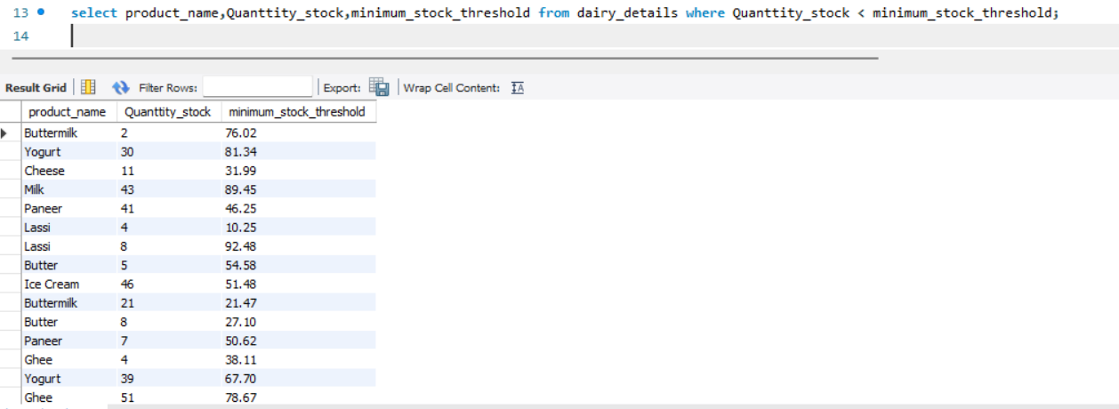
Observation:
- Products below the minimum stock threshold are identified to prevent stock shortages and improve inventory control.
- The product butter, ghee, buttermilk has the lowest quantity in stock.
Q5: Total reorder quantity required per product

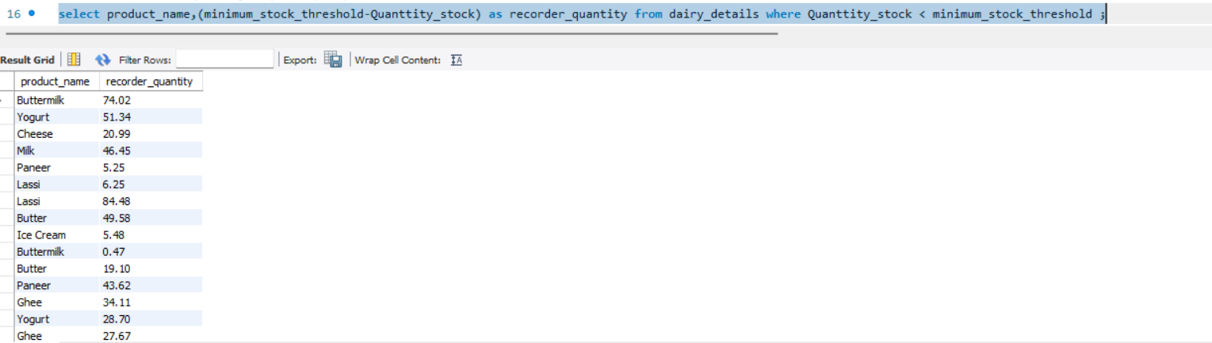
Observation:
- The dataset calculates reorder quantities required for each product, helping businesses maintain optimal inventory levels and avoid overstocking.
- The business is required to reorder most of their quantities of the products.
Q6: Which sales channel generates the most revenue?
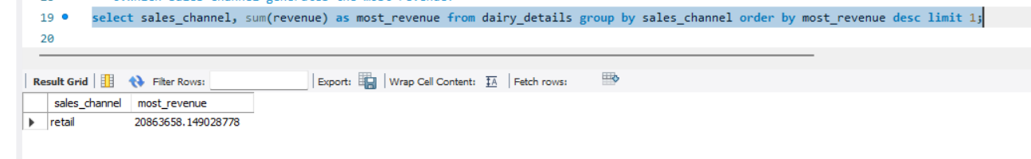
Observation:
- This question analyses which sales channel generates highest revenue, this allows the businesses to focus on their most profitable channel.
- The most of the sales of the business is done in the retail channel.

Q7: Top 5 customer locations by purchase volume

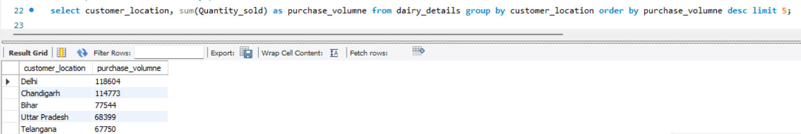

Observation:
- Top customer locations by purchase volume are identified, helping businesses target high-demand regions and improve regional marketing strategies.
- The customer location Delhi has the highest purchasing volume on the basis of quantity sold.

Q8: Average selling price per product?

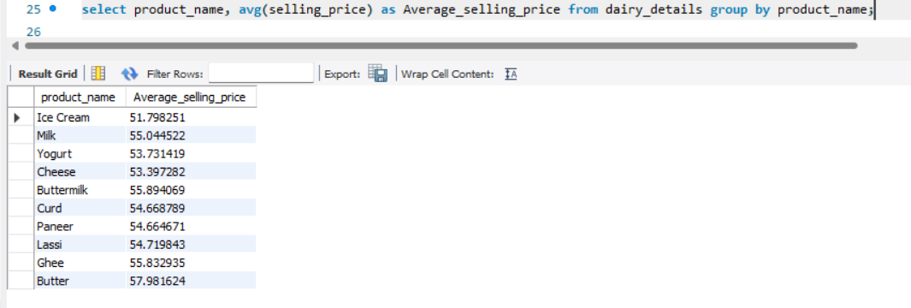
Observation:
Average selling price analysis helps evaluate pricing consistency and compare market competitiveness across products.

Q9: Compare selling price with listed price
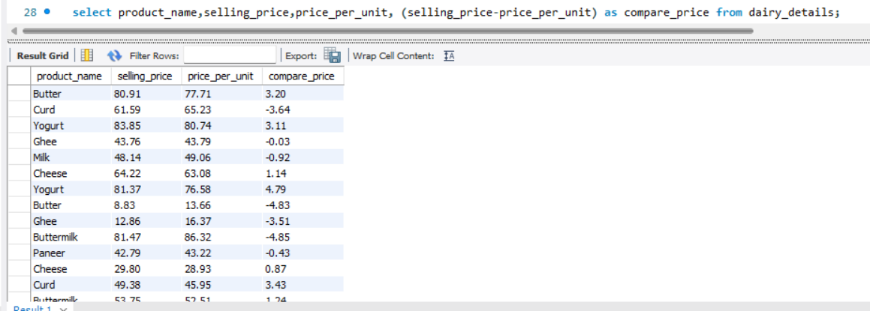
Observation:
Comparing selling price with listed price helps identify discount strategies, pricing gaps, and potential revenue leakage

Q10: Products with less than 10 days of shelf life remaining?
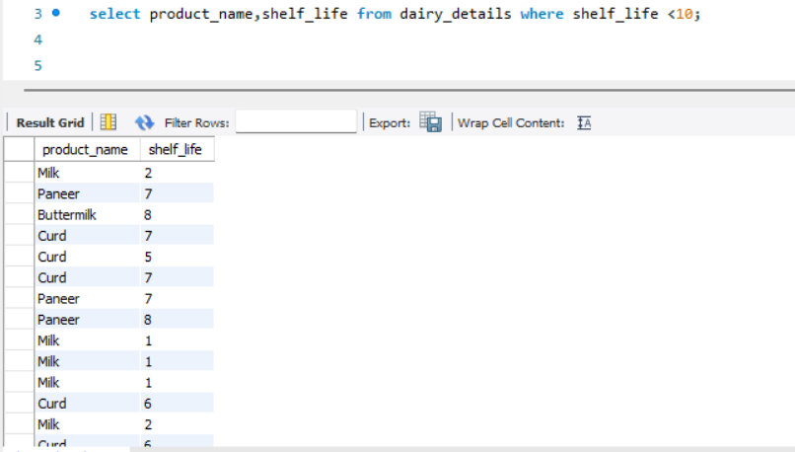
Observation:
Products with less than 10 days of shelf life remaining are identified to reduce wastage and improve inventory turnover
Q11: Average shelf life of Products?

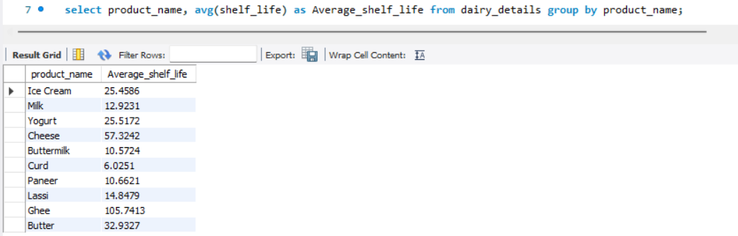
Observation:
- Average shelf life by product category helps businesses optimize storage, transportation, and inventory planning.
- The ghee product has the highest shell life and the curd has lowest shell life.
Q12: Average number of cows per farm size category?

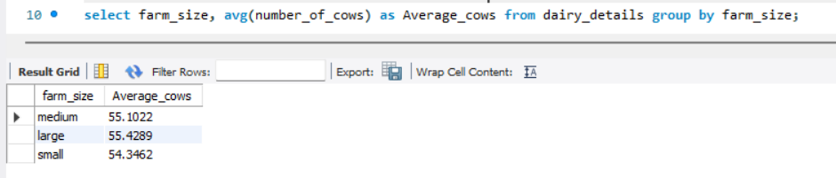
Observation:
- Average number of cows in each farm size help the business to understand their production capacity and farm efficiency.
- The average number of cows in each farm size are same.

Q13: Location with the largest total land area?

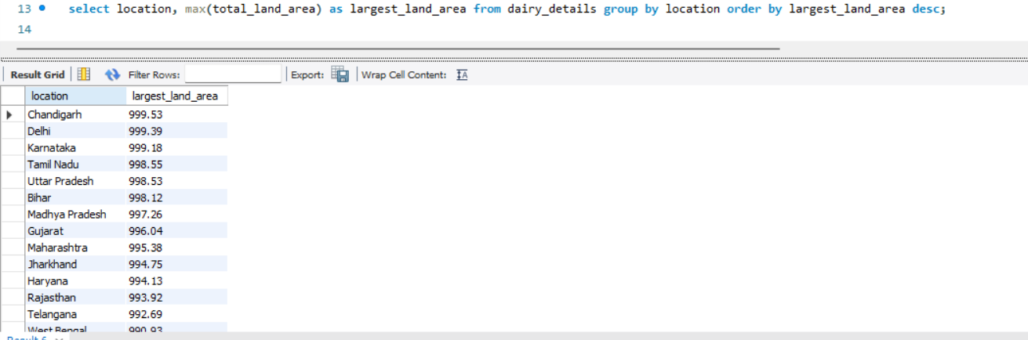
Observation:
- Locations with the largest land area are identified, helping analyze production scalability and resource utilization.
- The Chandigarh and Delhi location has the largest land area for the production of goods.

Q14: Top 3 locations by average production quantity?

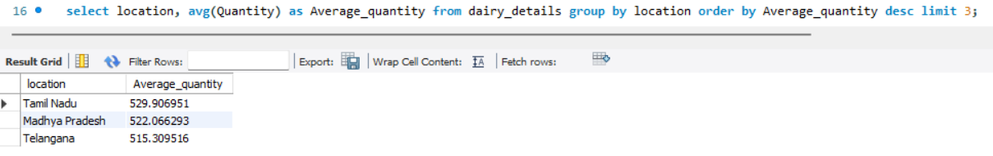
Observation:
- Top production locations are identified to determine regions with the highest dairy output and operational efficiency.
- The state Tamil Nadu has produce highest quantity among the others state.
Q15: Calculate profit for each product?

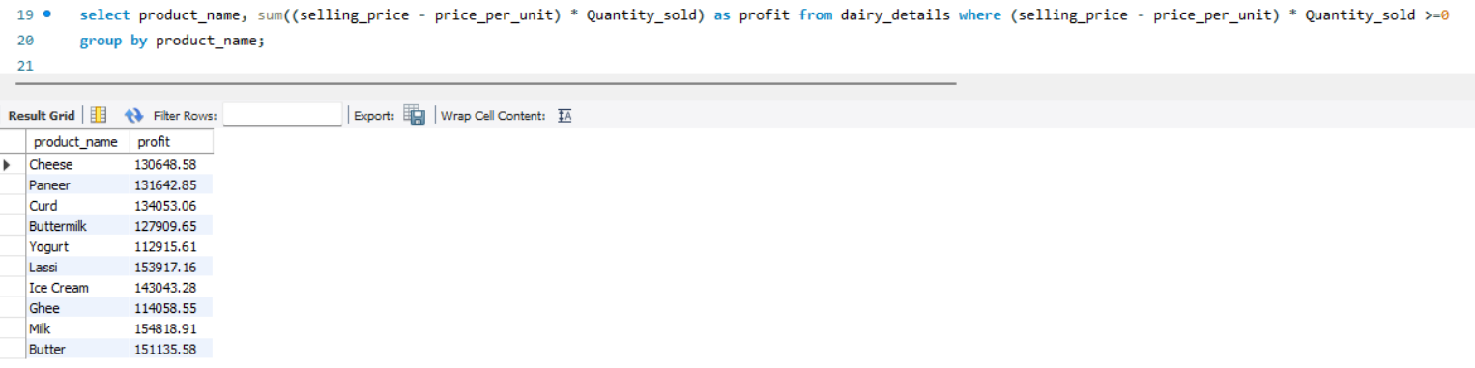
Observation:
- Profit for each product is calculated using SQL queries, helping businesses identify the most profitable products.
- The milk is considered as the most profitable product for the business.
Q16: Most profitable brand overall?

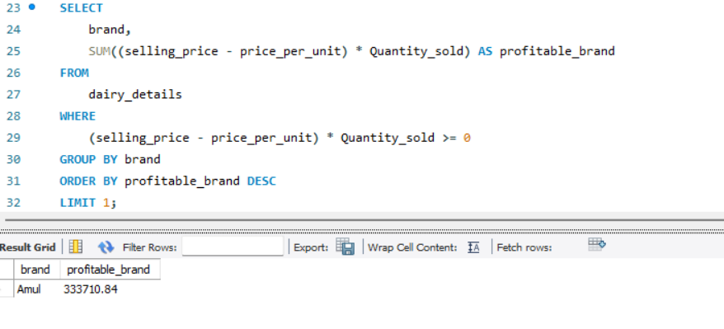
Observation:
- This highlights the overall most profitable brand, supporting strategic investment and brand expansion decisions.
- Most of the customer of the business are the willing to buy the products of Amul brand.
Q17: Yearly revenue growth?

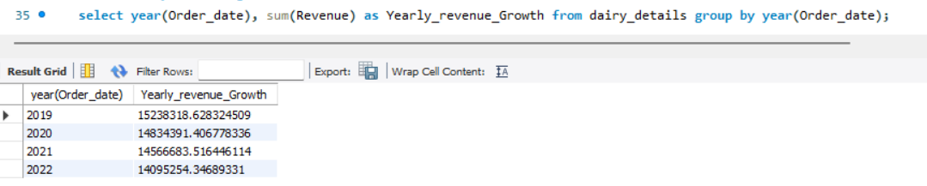
Observation:
- Yearly revenue growth analysis helps the business to compare their current year revenue with the previous year.
- The yearly revenue growth of the business is decrease from 2019 to 2022.
Q18: Best-selling product each year?

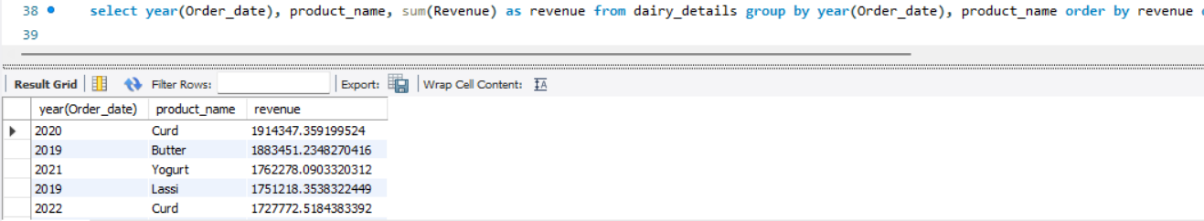
Observation:
- This question help the business to identify their top performing products in each year.
- The curd is considered as the hero product in 2020 and 2022 year.

Q19: Products that need immediate restock?

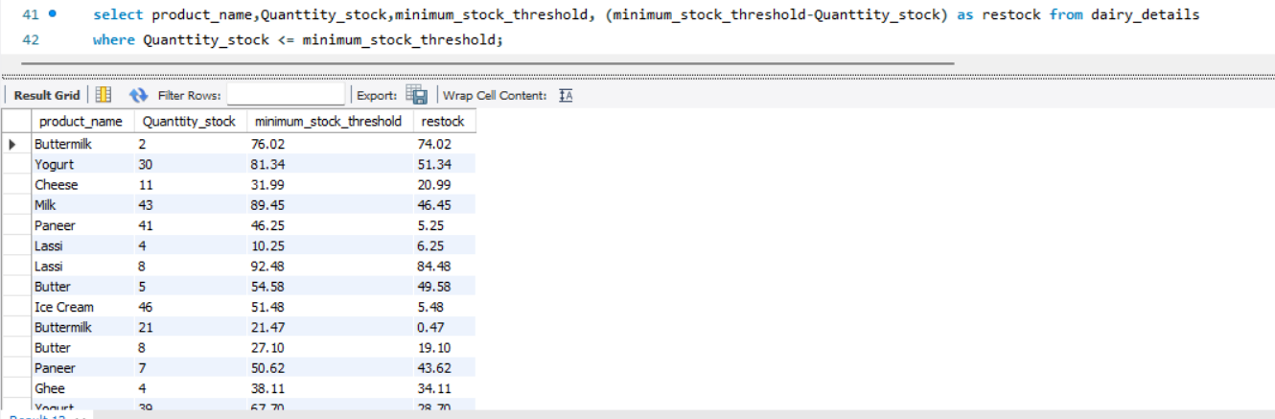
Observation:
- Products requiring immediate restocking are highlighted to improve supply chain responsiveness.
- The business is required to immediately restock the products which has high demand in the customers.

Q20: Identify expired products still in stock?
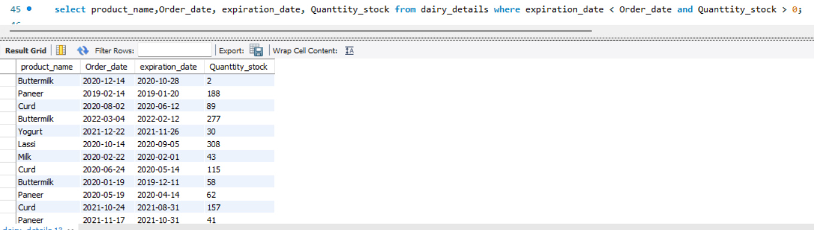
Observation:
- Expired products still available in stock are identified, helping businesses improve quality control and reduce losses.
- The Lassi product has the most expired quantity in stock.
Q21: Average shelf life per brand?
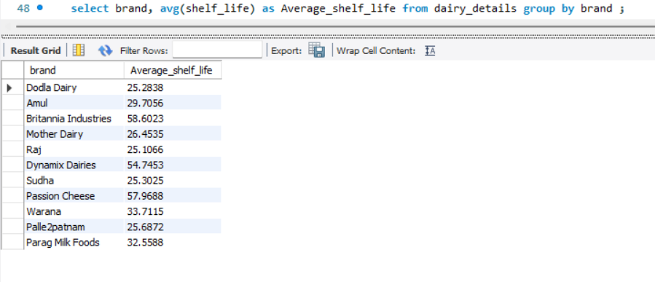
Observation:
- Average shelf life per brand helps to compare the product durability and storage effectiveness between brands.
- The passion cheese brand are offering a good average shelf life for their products.
Q22: Most popular product in each customer location?

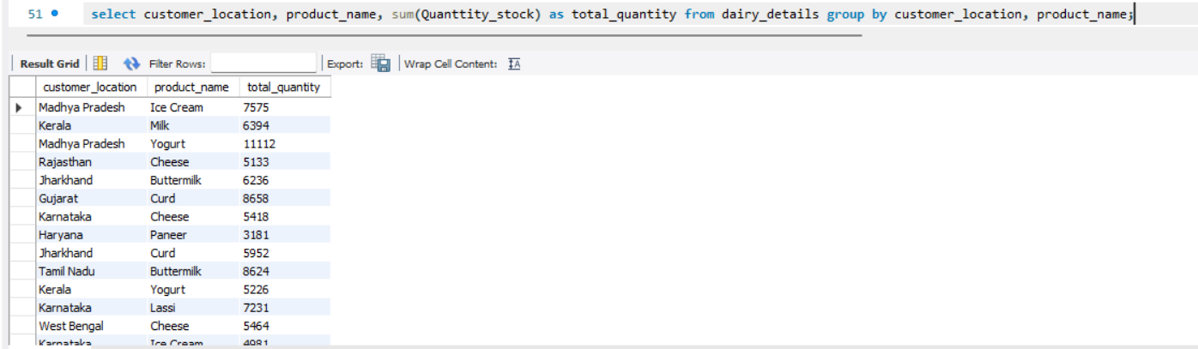
Observation:
- The most popular product in each customer location is identified, supporting location-based marketing and inventory planning.
- In Madhya Pradesh state the total quantity of yogurt is higher than the others state.

Tools & Features used
- SQL
- Excel Dataset
- Microsoft Word Documentation
- Aggregate functions, group by, order by
- Where clause for the conditions
Conclusion
This project successfully demonstrates how SQL can be used as a powerful analytical tool to extract meaningful business insights from a dairy industry dataset. By applying SQL queries to analyze sales, revenue, inventory, customer demand, pricing, shelf life, production, and profitability, the project converts raw data into actionable business information.

